**Experiment No. 7**

**Aim:**

Design a programmable digital data display system.

**Apparatus:**

Arduino, Breadboard, LCD, wires, variable resistance.

**Circuit Diagram:**

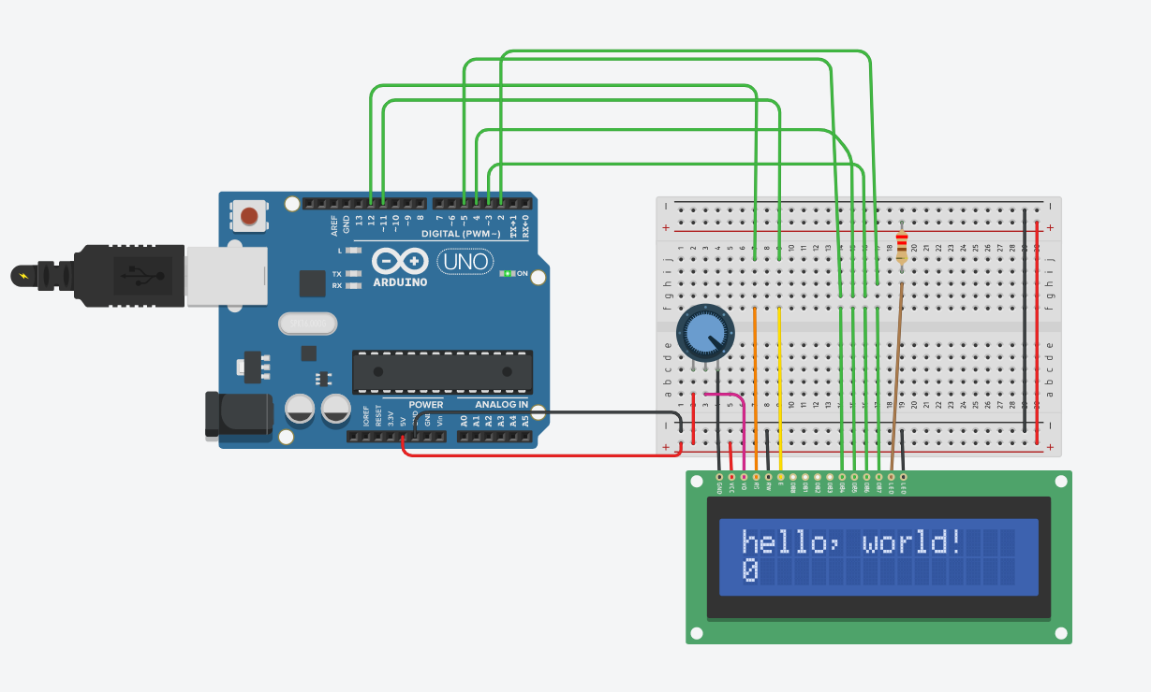

**Source code:**

**#include <LiquidCrystal.h>**

**LiquidCrystal lcd(12, 11, 5, 4, 3, 2);**

**void setup() {**

**lcd.begin(16, 2);**

**lcd.print("hello, world!");**

**}**

**void loop() {**

**lcd.setCursor(0, 1);**

**lcd.print(millis() / 1000);**

**}**

**Precautions:**

1. Don’t touch live wires and components.
2. Always do the connections without connecting the arduino with main supply.

**Problems Faced:**

1. In connecting wires to the breadboard due to lot of connectios to LCD.
2. Problem faced in uploading the code due to errors in coding.

**Solutions to problems faced:**

1. To solve the problem of connections, I focussed on each wire and do the connections.
2. To solve the error in coding, I declare the right pins as constants.

**Learning and outcomes:**

1. I learn how to write string on the LCD.
2. Also how to write two strings in two respective lines.